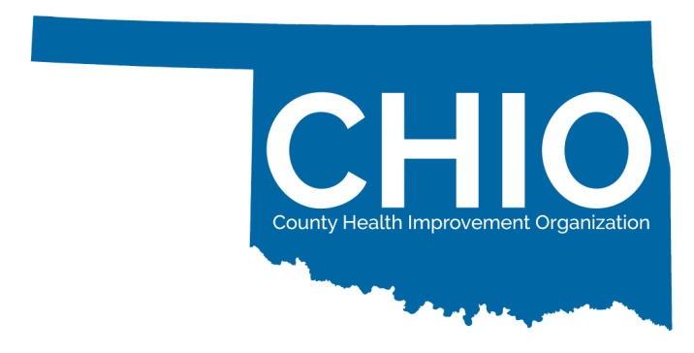
Certified Partnership
CHIO Certification Criteria Guidelines and Recommendations
To be considered a County Health Improvement Organization (CHIO), an organization must generally meet the following criteria. (Note: Exceptions must be approved by the Board of Directors of PHIO.)
1. Ideally, the organization should have a broad community health improvement mission such as a Turning Point partnership. Other organizations will be considered for approval by PHIO.
2. The organization must:
a. Be an independent non-profit (e.g. 501c3);
b. Establish an affiliation agreement with the Public Health Institute of Oklahoma (PHIO); or
c. Be affiliated with a non-profit partner that meets all of the other criteria.
3. The geographical area served should correspond to one county or a geographically contiguous cluster of no more than four counties and should not include counties covered by other CHIO certified organizations.
4. The organization’s mission should include improving the health and health care services available to all citizens within the geographic area served.
5. The organization must have a Board of Directors (BOD) that shall include representation from the following community sectors, if available, in the county or counties:
- Primary Care - One or more primary care clinician(s) (can be a physician, advanced practice nurse, or physician assistant) Committee;
- Public Health - The county health department administrator or designee;
- Mental Health Organization - The Community Mental Health Center or the Area Regional Prevention Center Director or designee;
- Social Services - The County Department of Human Services director or designee;
- Hospital Representative - The CEO of the hospital. If there is more than one hospital, this should be the Chair of a Hospital CEO Advisory Committee composed of the CEOs of all hospitals in the county or designee;
- Coalition representation - The Chairperson of the County Turning Point Coalition and/or other coalition member representative; and
- Other Community Representatives - important population subgroups, particularly under-represented minorities, and advocates for children and older adults

Recommended additional representation shall include the following:
- Representatives from faith communities
- Media representatives
- Economic Development/Business Representatives
- School Representative – Someone representing the local school system(s) in CHIO geographical service area, preferred superintendent level designee
- Federally Qualified Health Center representatives
- Representatives of higher educational institutions
6. The organization shall have a board or committee structure that assures it can both receive input from and effectively disseminate information to the identified board sectors and the communities they represent and serve. It is required that there shall be a standing Primary Care Advisory Committee (PCAC) or group similar to that includes representatives from at least 5 primary care practices or at least 50% of the primary care practices in the county/ies served by the CHIO. The Chair of the PCAC shall be a member of the BOD of the CHIO with both entities serving to exchange information and input. The chair shall provide input from the PCAC at each BOD meeting. That input could be obtained in a variety of ways (e.g. specific PCAC meetings, discussions at other meetings (e.g. hospital staff meetings), e-mails, personal contacts, etc.

7. The organization should endorse and adopt the County Health Improvement Plan (CHIP) for the County(s) (or group of counties). Note: Board members are encouraged to obtain training in the MAPP – Mobilizing Action through Planning and Partnerships assessment and planning process offered by the Oklahoma State Department of Health.
8. The organization must have a set of policies and procedures that define a process for deciding upon and prioritizing acceptance of and distribution of resources/funds.
9. The organization should be organized in such a way that there is an appropriate balance of influence from the agencies and organizations listed in requirement 5. That is, no single agency or organization represented on the Board should have undue influence over the assessment of health and health care priorities or opportunities.
10. The organization should make a statement of its plan to develop the capacity to recruit and supervise community volunteers (example: this may also be reflected in organization’s by-laws and or procedures) and its plan for sustainability.
CHIO re-certification is required every three years from Certification date.

All applications must be sent with required materials to info@publichealthok.org or mailed to:

Public Health Institute of Oklahoma
PO Box 60926
Oklahoma City, OK 73146
info@publichealthok.org

For more information visit www.publichealthok.org/CHIO 1/5/2017
