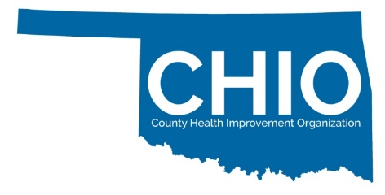
Certification Readiness Assessment Tool
Tell us a bit more about your community, this helps us to determine your readiness for CHIO Certification and to provide you a timeline for Certification process.

Coalition Name: ______________________ County(ies) served:________________________________________________
When, where does your Coalition meet: ________________________________
Primary Coalition Contact Info: _______________________________________
Social Media Outlets (Facebook, Instagram): ____________________________

1. ☐ YES ☐ NO Does your community organize around health improvement goals?

2. ☐ YES ☐ NO Are you 501(c)3 or does a separate 501(c)3 support your Coalition?

3. ☐ YES ☐ NO Do you serve at least one but no more than 6 rural counties?

4. ☐ YES ☐ NO Who do you have involved in your health improvement activities?

- Primary Care
- Health Department
- Mental Health
- Social Services
- Faith Community
- Philanthropic Groups
- Hospital
- Businesses
- Extension System
- Financial Institutions
- Long Term Care
- Civic Groups
- Elected Officials
- Media
- Law Enforcement
- Higher Education
- FQHC/Community Health Centers
- Youth Development
- Child Development
- Dept. Health & Human Services
- Public Schools

5. ☐ YES ☐ NO Do you have established communication channels to share information?

6. ☐ YES ☐ NO Do you have health care providers participating in your Coalition activities?

7. ☐ YES ☐ NO Are you engaged with your Community Health Needs Assessment or County Health Improvement Plan activities as a Coalition?

8. ☐ YES ☐ NO Do you have established policies and procedures or by-laws as a Coalition?

9. ☐ YES ☐ NO Does your Coalition support a Youth Advisory Board?
10. ☐ YES ☐ NO Does your Coalition have the capacity to recruit & supervise community volunteers?

11. ☐ YES ☐ NO Does your Coalition have the ability to host virtual, web-based meetings?

12. ☐ YES ☐ NO Is your Coalition interested in participating in no-cost Continuing Education?
Questions? Interested in applying?
Laura Ross-White at (918) 631-2681
or Laura-RossWhite@utulsa.edu
(405) 249-6851 or info@publichealthok.org
For more information visit www.publichealthok.org/CHIO

