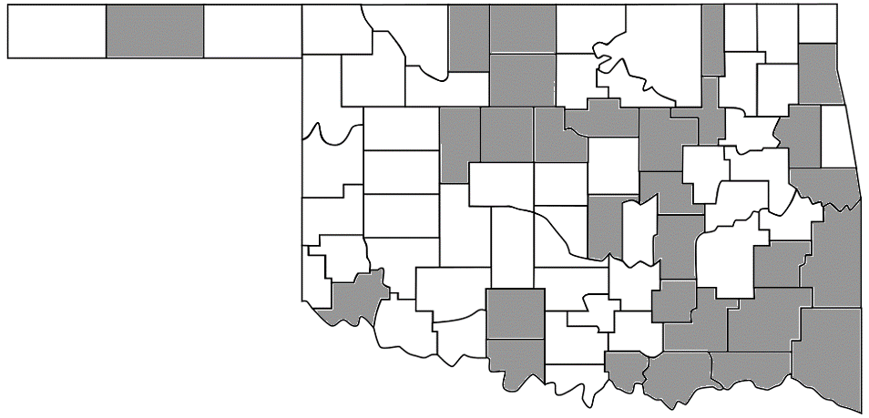

University of Oklahoma Health Sciences Center

University of Tulsa

Major

c

Oklahoma State University Center for Health Systems Innovation

Creek

Payne

Pawnee

c

Rogers

Mayes

c

Delaware

Beckham

Public Health Institute of Oklahoma

**Rural Health Association**

Caddo

c

Washita

Grady

c

Cleveland

c

Custer

Oklahoma

c

Canadian

c

Rural Health Network of Oklahoma

Bryan

Love

c

**We cannot do it alone…  
But can we do it  
together?  
  
Consider localized or regionalized   
approaches to building your stakeholder community  
  
Power and influence in numbers**

Nowata

Wagoner

c

Adair

c

Craig

c

Washington

McIntosh

c

Haskell

c

Le Flore

L

Pushmataha

Choctaw

Atoka

Coal

Hughes

c

Okfuskee

c

Lincoln

c

Kay

c

Stephens

Harmon

Pittsburg

c

Ottawa

c

Muskogee

c

Okmulgee

c

Cherokee

Sequoyah

Marshall

Latimer

Johnston

c

Seminole

c

Pontotoc

c

McCurtain

Tulsa

Pottawatomie

Osage

c

Noble

c

Garvin

c

Carter

c

Murray

c

McClain

c

Jefferson

Cotton

Tillman

Comanche

Kiowa

Dewey

Blaine

Logan

Kingfisher

Garfield

Grant

Alfalfa

Texas

Jackson

Greer

Roger Mills

Ellis

Woodward

Woods

Harper

Beaver

Cimarron