Guidance for Community Site Testing for COVID-19,
Project: CATCH-UP, Site Location: City Name, OK
Anticipated number of tests: Not to exceed 100
___________________________________________________________
*For the purposes of this guidance document, community members who wish to be tested will be referred to as “patient”
1) Provide Consent forms to patient: explain to patient that the code word will be used to confirm their identity when communicating test results.
Spanish: https://publichealthok.org/wp-content/uploads/psp/COVID-19-Consent-and-Information-Sheet-Spanish-rev-07-10-2020.pdf
English: https://publichealthok.org/wp-content/uploads/psp/COVID-19-Consent-and-Information-Sheet-rev-07-10-2020.pdf
PATIENT KEEPS CONSENT FORM as it includes education.
Note: Volunteer will mark on Screening form (ODH-1391-2-COVID-19-Screening-Form-7-20-2020) to acknowledge the receipt of VERBAL CONSENT to testing and that the information sheet was provided to patient.
2) Volunteer will ask patient questions to Complete screening form (access at (https://publichealthok.org/wp-content/uploads/psp/ODH-1391-2-COVID-19-Screening-Form-7-20-2020-fillable.pdf). OSDH Screening Form will also be used to fill out PHL COVID-19 Testing and Screening Form at PHL COVID-19 Test Requisition and Patient Screening Form (oklahoma.gov)
* Clinic Name: County Name/City Name CATCH-UP
* Specimen Number (leave blank if not using an online accessioning system)
* Initials of Nurse collecting specimen
* Write down the code word that was provided during verbal consent
* At a minimum, must include patient name, date of birth and phone number.
* If patient is unsure if they are symptomatic, ask if they are experiencing any of the following:
- Fever or chills
- Cough
- Shortness of breath or difficulty breathing
- Fatigue
- Muscle or body aches
- Headache
- New loss of taste or smell
- Sore throat
- Congestion or runny nose
- Nausea or vomiting
- Diarrhea
*Under TESTING/SAMPLE COLLECTION Mark the first two boxes : COVID-19 TEST, NP
3) Specimen Collection
Use synthetic fiber tip swab with a plastic or aluminum shaft to collect a Nasopharyngeal Swab
Place one swab only in viral transport media (tube with pink liquid)
Volunteer labels Viral Transport Media (Tube with liquid) with two patient identifiers: First and Last Name and DOB
RN reviews screening form and asks patient to identify name and DOB while confirming specimen label.
If patient has a large amount of mucus, ask to blow nose before specimen collection.
With the thumb of one hand, gently elevate the tip of the patient’s nose and then gently insert the NP swab into the nostril.
Guide the swab backward and upward along the nasal septum until a distinct resistance is met, hold it there for a few seconds then with a rotating motion, gently remove it.
Immediately, place swab in the labeled viral transport tube.
Break off the excess shaft of the swab so that the tube can be capped; swab must be present in transport medium to be acceptable for testing.
Secure the cap of the tube (tightly) and secure with Parafilm to prevent leakage during transport.
RN labels transport media tube with date, time of collection and initials.
Place labeled specimen in biohazard transport bag and seal.
After collection, store specimens under refrigeration at 2-8 degrees Celsius ( 35.6-46.4 degrees Fahrenheit) for up to 72 hours. (See below for specimens that will be store over 72 hors)
4. Provide patient with Survey card
5. Complete the OSDH PHL Test Requisition Form (ODH 419). Accessible at https://www.phin.state.ok.us/Accessioning_to_Labware_fill_PDF_only/Views/MainPage.aspx
If necessary, use hardcopy at http://phl.health.ok.gov (Forms)
Information on form MUST match patient identifiers used to label the specimen.
Practitioner Name: Physician Name, MD or DO; NPI: If not available, look up at https://npiregistry.cms.hhs.gov/
Facility Name: County Name/City Name CATCH-UP
Collection Date, Time and RN initials MUST MATCH specimen label
Place a check mark next to Nasopharyngeal swab
Complete symptoms and associated risk factors based on information obtained in screening form, if unknown leave blank.
Fold completed PHL COVID-19 Testing and Screening form in half and place in OUTSIDE pocket of biohazard bag with associated specimen.
Do not roll up, fold or tape the specimen bags. For ease of handling, it is best for the specimen bag to remain flat and stacked with other specimen bags.
DO NOT place requisition in the same compartment as specimen.
6. Specimen Transport to local Health Department
Specimens must be stored in a designated refrigerator or cooler for specimen storage only.
Before leaving site double bag specimens or place in a CATEGORY B box, as available and transport in cooler.
Complete Chain of Custody Form ( available at https://publichealthok.org/wp-content/uploads/psp/Chain-Of-Custody-Form.pdf) and place with specimens.
Transport to local health department for pick up by routine courier service and transport to PHL.
If specimens will not arrive to the laboratory within 72 hours of collection, they should be stored frozen at -70°C and shipped on dry ice.
RESOURCES
Oklahoma State Department of Health COVID-19 Hotline: 877-215-8336
PHL Forms: https://oklahoma.gov/health/prevention-and-preparedness/public-health-laboratory/forms.html

Forms:
- Hard Copy Consent Form (Provided to Patient): Spanish: https://publichealthok.org/wp-content/uploads/psp/COVID-19-Consent-and-Information-Sheet-Spanish-rev-07-10-2020.pdf
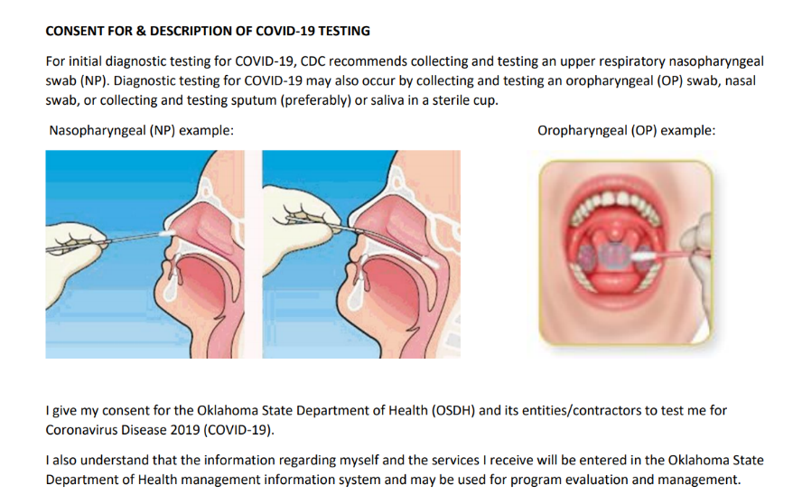
English: https://publichealthok.org/wp-content/uploads/psp/COVID-19-Consent-and-Information-Sheet-rev-07-10-2020.pdf

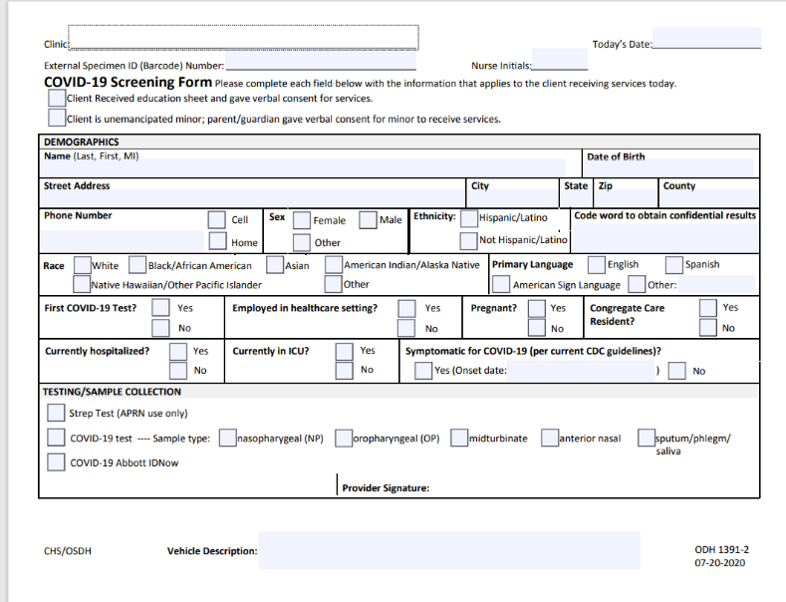
- OSDH COVID-19 Screening Form (ODH-1391-2-COVID-19-Screening-Form-7-20-2020). Available at ODH-1391-2-COVID-19-Screening-Form-7-20-2020-fillable.pdf (publichealthok.org).
Volunteer fills out based on information provided by patient at a safe distance.
* Important because this is the form where we indicate patient consent and make note of code word for results

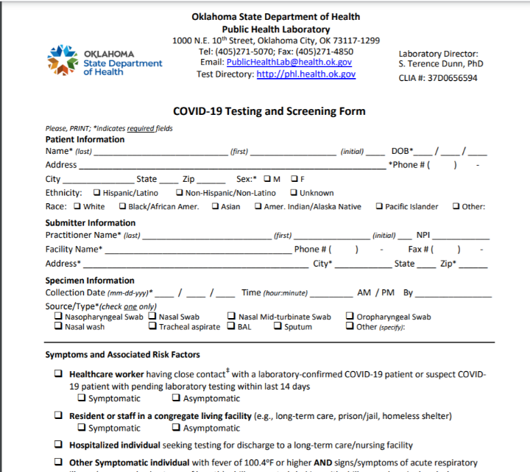
- PHL Testing and Screening Form. Can be filled out using information from OSDH screening form and specimen label. FOLD AND PLACE COMLETED FORM IN OUTISDE POCKET OF BIOHAZARD SPECIEMN BAG

- Complete ONLINE lab requisition form and submit electronically
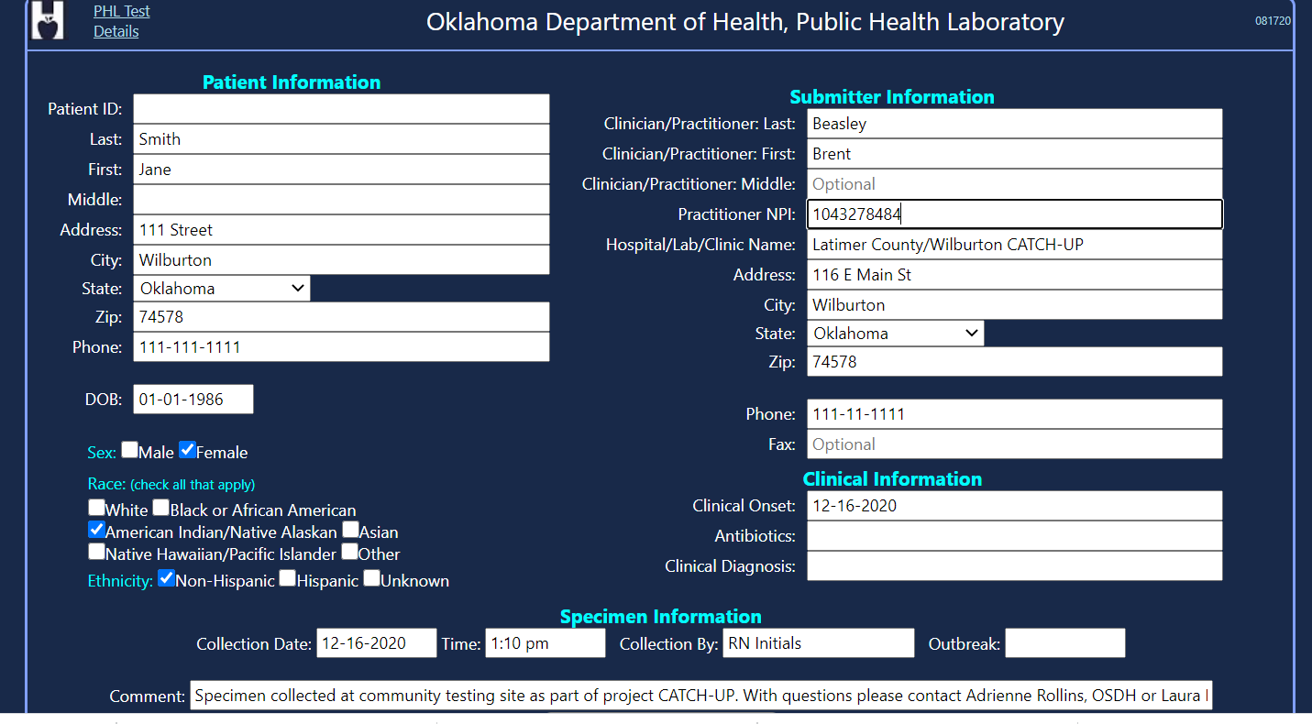

Points of perspective to remember:

Patient
Well-informed: what to expect, how to find resources, approximate time for results, without explicit guidance, suggest communicating a time of 5 days
Social needs are met where available
Encouraged to submit survey
Volunteers
Maintaining proper distance when completing forms and providing information
Wearing appropriate PPE
Readily accessible hand washing/sanitizing stations
Lab
Complete and accurate specimen labeling: patient identifiers First and Last Name (verified by sampler), RN initials, Date and time of collection
Identifiers must appear on both the specimen container and the associated requisition form.
Complete and accurate Requisition Form with information matching specimen
Fax request form submitted to lab for OUHSC OSCTR to receive results ensuring that Site Name matches Site Name on Lab requisition and Testing and Screening Form

Health Department (Local and State)
Results accessed in PHIDDO
Results communicated by OSCTR team
Complete Chain of Custody Form and double bagged specimens for proper specimen handling

