MTX System Management Volunteer
Viewing/Processing Patients/Printing Barcode label through the Portal:
Patient specimen collection:
MTX System Label and Specimen Collection PROCESS NOTE: Site process and volunteer best practice will determine when label is printed. If the barcode label is printed AFTER specimen is collected and RN has initialed specimen tube, DO NOT cover RN initials or patient’s name when the new barcode label is placed. Place the barcode label just below the RN labeled information ensuring that enough space is left to visibility see the specimen swab within the tube. If the barcode label is printed and placed on the specimen tube BEFORE collection, the RN will verify the information and initial ON the barcode label.
Select Patient Name: PLEASE KNOW THE SYSTEM MAY PLACE THEM IN “RAPID TEST”. IF NOT SEEING THEIR NAME UNDER THE “PCR” TAB, PLEASE CLICK THE “RAPID TEST” BUTTON AND CHECK FOR THEIR NAME THERE. If they are there, during “In Progress” select “PCR” on the Test Type AND BE SURE TO INCLUDE THE OTHER FIELDS BELOW (Sample collected by, Specimen type, lab, verbal consent) before you hit “Complete”.
IN THE OKLAHOMA STATE COVIDE PORTAL: When the specimen for the patient is collected, then the test site user will mark it as “In Progress”. Once the user clicks on In Progress button below screen will appear where Patient has to enter following details:
● Test Type – PCR (Make sure it still not in Rapid Test!) on which testing site user will have flexibility to change the testing type.
● Sample Collected By - name of the sample collection agent/ nurse
● Specimen Type Description - Nasopharyngeal
● Lab Name - its defaulted to “Public Health Lab” for PCR
● Verbal Consent - Unless Patient provides the verbal consent, the testing site user cannot move ahead with sample collection.
Once marked “Complete,” a barcode will be generated and all the patient information should be sent to the public health lab. To print label with barcode, see instructions below. Label the specimen according to the Specimen Collection process above.
To print specimen label from MTX system to Zebra Printer:
Once a patient is “Complete” you should be able to click on the patient and “View barcode” and print.
To print:
Save barcode as pdf in Abobe from browser window.
Open PDF in the new file, hit “Print”. Set to print to Zebra printer according to the specifications:

Print Zebra printer “Custom Scale” 40%

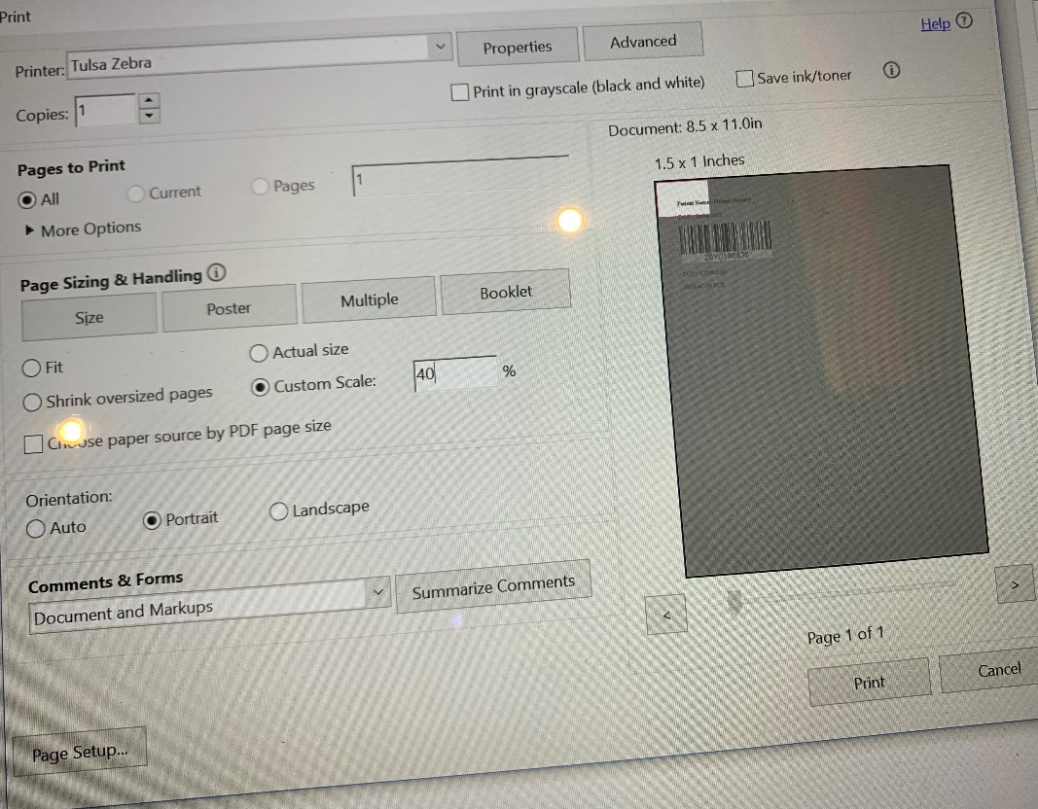
Zebra Printer Properties – Options : Check all these below. Set Paper format to “inch” Width “1.50” Hight “1.00”
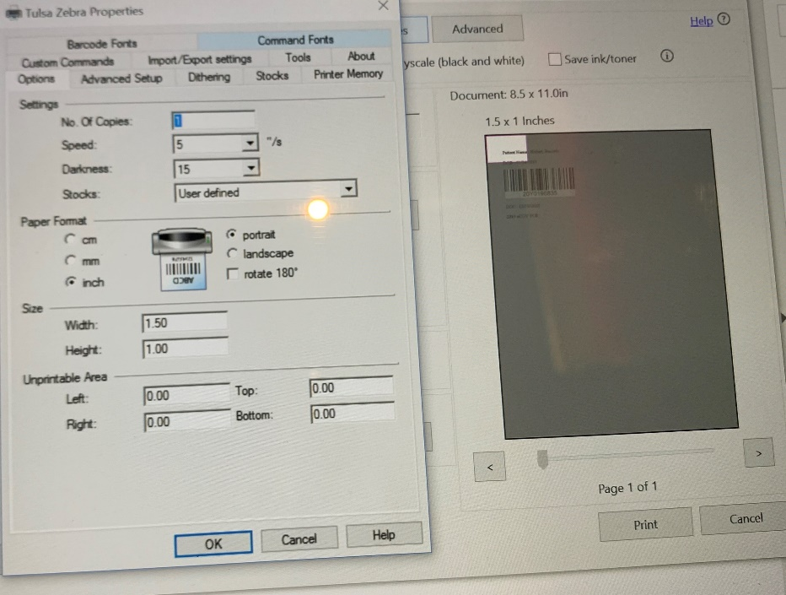
Label Placement instructions:
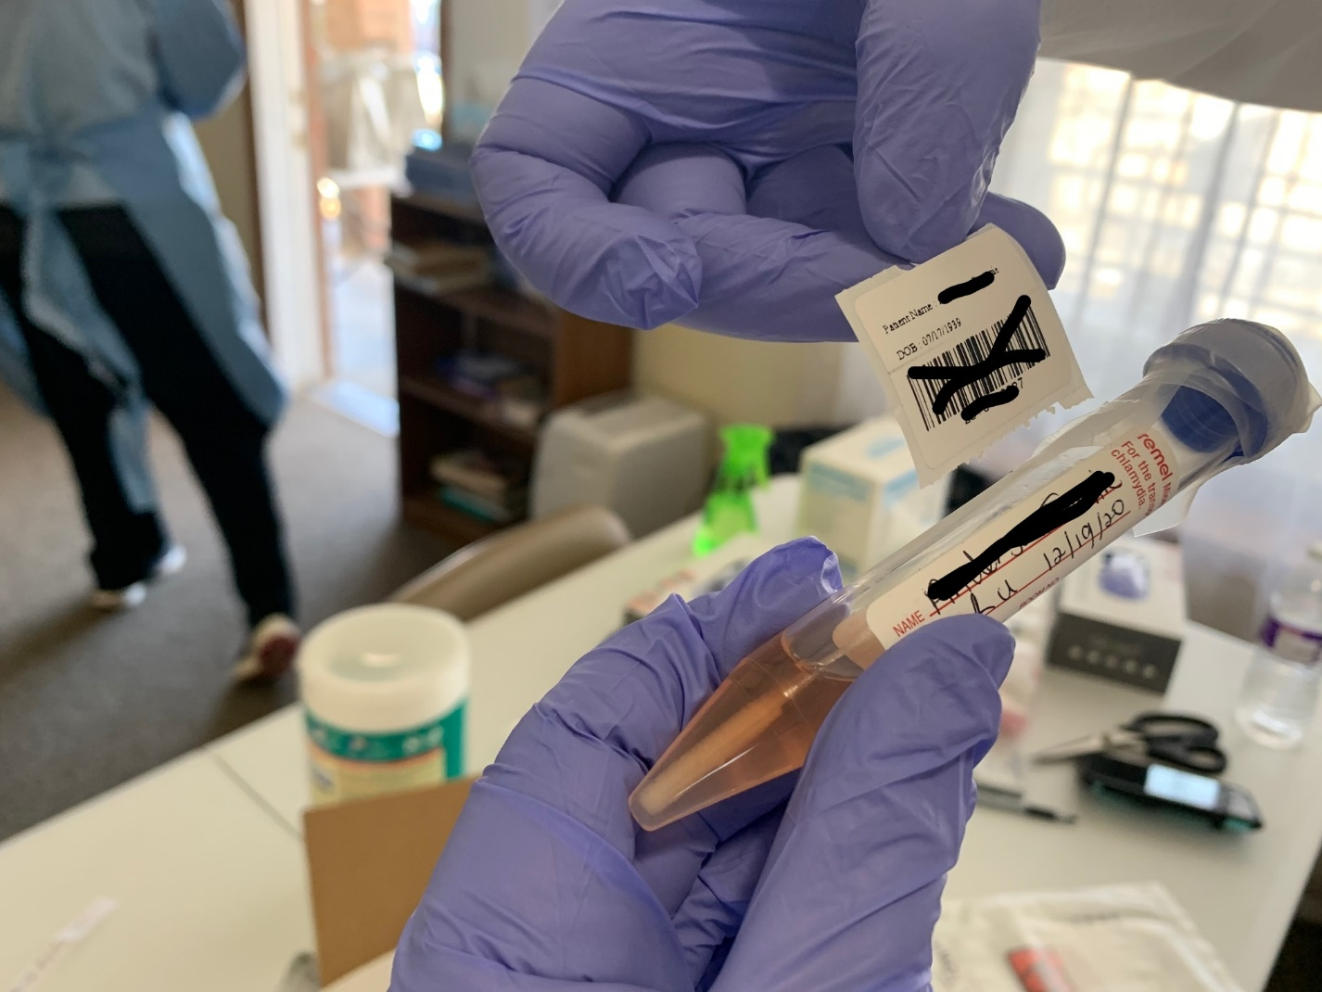
Make sure on the original tube label – Along with person’s name, has date of collection on tube, and collector’s (nurse) initials. Do NOT cover this hand-written info with the new barcode label.

