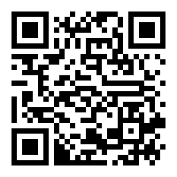
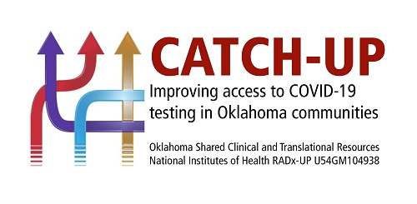

Welcome! Please follow these steps to register for the test and get your results. If you do not have an email address or a mobile phone number, please let our staff know.
- Register for an account at this website (or scan QR code above): https://osdh.force.com/selfPortal/s/selfregistration
  - Complete the required information (First and last name, mobile phone number and email address)
  - Submit your information
- You will then receive an email and/or a text message with a link to register at the portal. You will also be provided a participant ID (a “P” number, example: P-11111). You can note this number at the bottom of the form.
  - Click the link in the message
  - Enter your Participant ID, email address (use the same one you signed up with), and create a password (password must be 10 characters long and include letters, numbers and a special character)
  - Click Register
- Complete the next few pages of information
  - Consent form (you must check the box to consent to register)
  - Personal information (complete all fields marked with *)
  - Patient history form (complete all fields marked with *)
- Schedule your test
  - Pick Location – choose the name of this testing site
  - Choose an appointment time close to the current time
  - Click Schedule and Submit – you’ll then receive a confirmation email and/or text
    - If you need to schedule a family member who is with you for testing today that does not have an email or mobile number (or is a minor) choose “schedule another person” (top right corner of the screen) and complete the information for that person. Be sure to note their Participant ID number, too.
- Get your results
  - After your test is collected you should receive an email and/or text to let you know your results are ready (may take up to 72 hours after the event).
  - Click the link or go to https://osdh.force.com/covid/s/okcp-login to log in using your email address and password.
NOTES: Please note the following information to help you get your test results.
Email address used to register:___________________________________________________________
Your Participant ID:_____________________________________________________________________

