Guidance for Community Site Testing for COVID-19,
MTX SYSTEM ON-SITE REGISTRATIONS & LABEL PRINTING
Project: CATCH-UP
Anticipated number of tests: Not to exceed 100
___________________________________________________________
*For the purposes of this guidance document, community members who wish to be tested will be referred to as “citizen” to be consistent with OSDH MTX platform terminology. The platform will be referred to as the “Oklahoma State COVID Portal.”
1) Provide Consent forms to Citizen: Citizen will consent within the Oklahoma State COVID Portal but this sheet offers valuable, visual information and resources and may still be useful to provide. PLEASE NOTE: THEY WILL NOT NEED TO PROVIDE OR RECORD A CODE WORD. Consider crossing out that section of the form or letting them know that it is not applicable.
Spanish: https://publichealthok.org/wp-content/uploads/psp/COVID-19-Consent-and-Information-Sheet-Spanish-rev-07-10-2020.pdf
English: https://publichealthok.org/wp-content/uploads/psp/COVID-19-Consent-and-Information-Sheet-rev-07-10-2020.pdf
CITIZEN KEEPS CONSENT FORM as it includes education.

2) If Volunteer is adding a contact at the test site:
Log in to test site platform at https://osdh.force.com/TestingSite/s/oktc-login
You will see the site name listed as: OUHSC CATCH-UP, (LOCATION)
Access complete user guide at: https://publichealthok.org/wp-content/uploads/2020/12/Oklahoma-State-Testing-Site-COVID-Portal-User-Guide-1.pdf
Quick steps below:
* Select “Create Contact” on the left
* Contact type is “COVID CITIZEN”
* Complete information and make sure to select boxes to confirm that citizen will receive information via email or SMS text message or both.
* Note required fields are: FIRST NAME, LAST NAME, DOB, EMAIL, PHONE NUMBER, GENDER, ETHNICITY, COUTNY, STATE, ZIP and all HISTORY items.
* Patients are required to verify their accounts by email address. If patient does not have an email address, it is possible for them to be added under the account of someone who does have an email account, with whom they are comfortable with, such as a family member.
* If patient is unsure if they are symptomatic, ask if they are experiencing any of the following:
- Fever or chills
- Cough
- Shortness of breath or difficulty breathing
- Fatigue
- Muscle or body aches
- Headache
- New loss of taste or smell
- Sore throat
- Congestion or runny nose
- Nausea or vomiting
- Diarrhea
*Submit and patient will be placed into the next available time slot for NP-PCR testing.
3) Specimen Collection
Use synthetic fiber tip swab with a plastic or aluminum shaft to collect a Nasopharyngeal Swab
Place one swab only in viral transport media (tube with pink liquid)
Volunteer labels Viral Transport Media (Tube with liquid) with two patient identifiers: First and Last Name and DOB
RN reviews label and asks patient to identify name and DOB while confirming specimen label.
If patient has a large amount of mucus, ask to blow nose before specimen collection.
With the thumb of one hand, gently elevate the tip of the patient’s nose and then gently insert the NP swab into the nostril.
Guide the swab backward and upward along the nasal septum until a distinct resistance is met, hold it there for a few seconds then with a rotating motion, gently remove it.
Immediately, place swab in the labeled viral transport tube.
Break off the excess shaft of the swab so that the tube can be capped; swab must be present in transport medium to be acceptable for testing.
Secure the cap of the tube (tightly) and secure with Parafilm to prevent leakage during transport.
RN labels transport media tube with date, time of collection and initials.
Place labeled specimen in biohazard transport bag and seal.
After collection, store specimens under refrigeration at 2-8 degrees Celsius ( 35.6-46.4 degrees Fahrenheit) for up to 72 hours. (See below for specimens that will be store over 72 hors)
MTX System Label PROCESS NOTE: Site process and volunteer best practice will determine when label is printed. If the barcode label is printed AFTER specimen is collected and RN has initialed specimen tube, DO NOT cover RN initials or patient’s name when the new barcode label is placed. Place the barcode label just below the RN labeled information ensuring that enough space is left to visibility see the specimen swab within the tube. If the barcode label is printed and placed on the specimen tube BEFORE collection, the RN will verify the information and initial ON the barcode label.
IN THE OKLAHOMA STATE COVIDE PORTAL: When the specimen for the patient is collected, then the test site user will mark it as “In Progress”. Once the user clicks on In Progress button below screen will appear where Patient has to enter following details: (If not seeing the patient in the PCR tab, check the Rapid Test tab and be sure to move them to PCR Test while in “In progress”).
● Test Type – PCR (Make sure not Rapid Test!) on which testing site user will have flexibility to change the testing type.
● Sample Collected By - name of the sample collection agent/ nurse
● Specimen Type Description - Nasopharyngeal
● Lab Name - its defaulted to “Public Health Lab” for PCR
● Verbal Consent - Unless Patient provides the verbal consent, the testing site user cannot move ahead with sample collection.
Once marked “Complete,” a barcode will be generated and all the patient information should be sent to the public health lab. To print label with barcode, see instructions below. Label the specimen according to the “3) Specimen Collection” section above.
4) To print specimen label from MTX system:
Once a patient is “Complete” you should be able to click on the patient and “View barcode”. To print:
Save barcode as pdf in Adobe from browser window.
Open PDF in the new file, hit “Print”. Set to print to Zebra printer according to the specifications:
“Print” according to the specifications for the zebra printer:
Print Zebra printer “Custom Scale” 40% “Portrait”
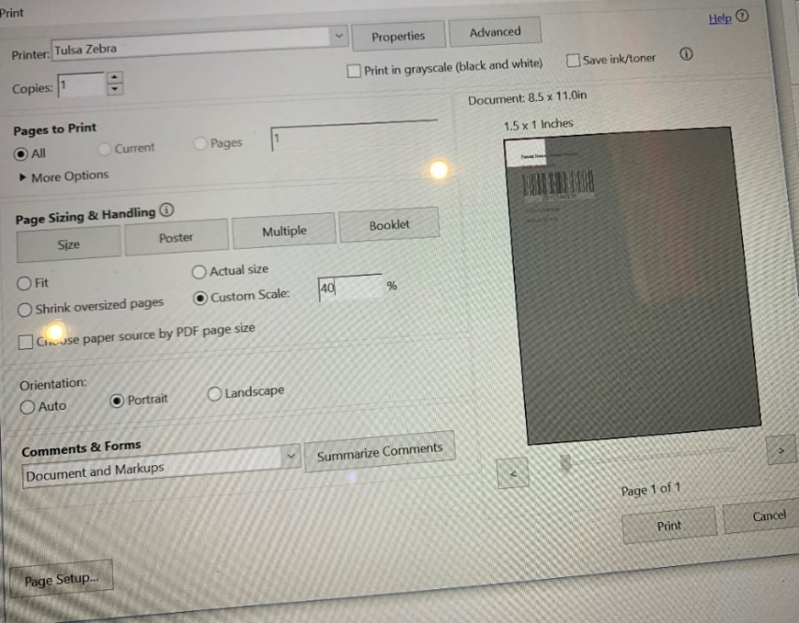
Zebra Printer Properties – Options: Check all these below. Set Paper format to “inch” Width “1.50” Hight “1.00” Portrait Speed “5” Darkness “15”
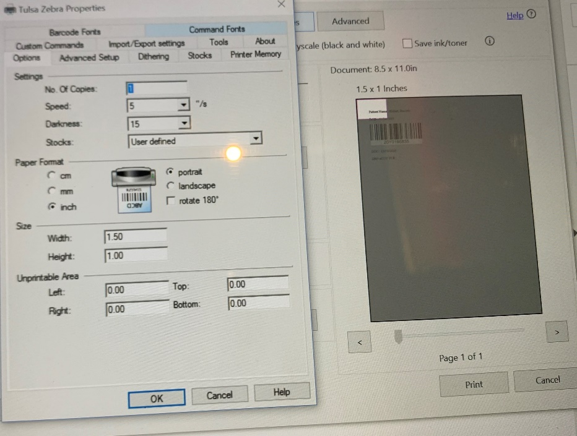
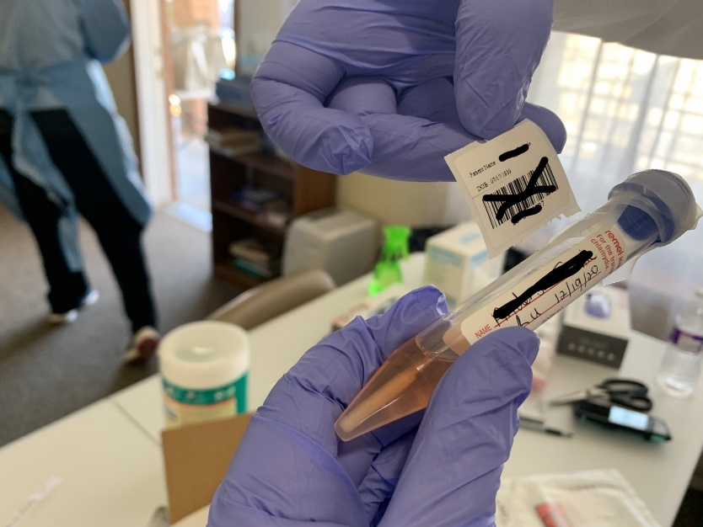
Make sure on the original tube label – Along with person’s name, has date of collection on tube, and collector’s (nurse) initials. Do NOT cover this hand-written info with the new barcode label.

5) Provide patient with Survey card and OUHSC MTX CATCH-UP Flyer for Users. This flyer will explain how to complete the registration process so they can log in later and access their results. Depending on how the system is operating, it may be best to inform citizens that there are NO FURTHER APPOINTMENTS NEEDED and that if the system automatically assigns them a testing appointment as they complete their registration, it can be ignored and will be canceled.
Flyer can be found at https://publichealthok.org/wp-content/uploads/psp/OUHSC-MTX-CATCH-UP-Flyer-for-Users.pdf
Do not roll up, fold or tape the specimen bags. For ease of handling, it is best for the specimen bag to remain flat and stacked with other specimen bags.
DO NOT place paperwork in the same compartment as specimen.
6. Specimen Transport to local Health Department
Specimens must be stored in a designated refrigerator or cooler for specimen storage only.
Before leaving site double bag specimens or place in a CATEGORY B box, as available and transport in cooler.
Complete Chain of Custody Form ( available at https://publichealthok.org/wp-content/uploads/psp/Chain-Of-Custody-Form.pdf) and place with specimens.
Transport to local health department for pick up by routine courier service and transport to PHL.
If specimens will not arrive to the laboratory within 72 hours of collection, they should be stored frozen at -70°C and shipped on dry ice.
BACK-UP CONSIDERATIONS
* If a citizen has a mobile device and access to their email and chooses to self-register. They can do so following the Oklahoma State Citizen Portal COVID User Guide available at https://publichealthok.org/wp-content/uploads/2020/12/Oklahoma-State-Citizen-Portal-COVID-User-Guide-1-1.pdf. The citizen portal can be found at: https://osdh.force.com/selfPortal/s/selfregistration

* If the Oklahoma State COVID portal is experiencing technical difficulties or in the event of an internet connectivity issue or outage, specimens may be collected using the PAPER PROCESS found at https://publichealthok.org/wp-content/uploads/2020/12/Testing-site-process_Paper.docx.

* If the Oklahoma State COVID portal “Add Contact” functionality is experiencing issues but the site would like to proceed with the use of the portal without slowing down collection. Information can be gathered on citizens using a formatted spreadsheet with appropriate in-cell validation to ensure correct filed entry and uploaded in a batch into the portal following collection. An example spreadsheet can be found at https://publichealthok.org/wp-content/uploads/2020/12/MTXContactUpload.xlsx
If organization name is required and not applicable to citizen, we suggest entering UNKNOWN
RESOURCES
Oklahoma State Department of Health COVID-19 Hotline: 877-215-8336
PHL Forms: https://oklahoma.gov/health/prevention-and-preparedness/public-health-laboratory/forms.html
Hardcopy Forms:
- Hard Copy Consent Form (Provided to Patient): Spanish: https://publichealthok.org/wp-content/uploads/psp/COVID-19-Consent-and-Information-Sheet-Spanish-rev-07-10-2020.pdf
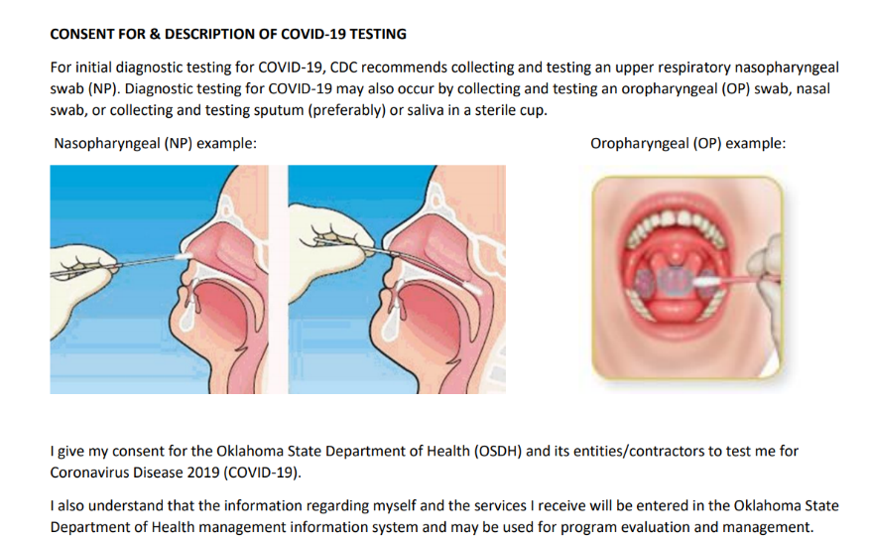
English: https://publichealthok.org/wp-content/uploads/psp/COVID-19-Consent-and-Information-Sheet-rev-07-10-2020.pdf

- PHL Testing and Screening Form. LAB REQISITION FORM TO BE USED WHEN UNABLE TO PRINT BARCODE FOLD. PLACE COMLETED FORM IN OUTISDE POCKET OF BIOHAZARD SPECIEMN BAG. Make sure Submitter Facility Name is listed as OSCTR-OSCTI
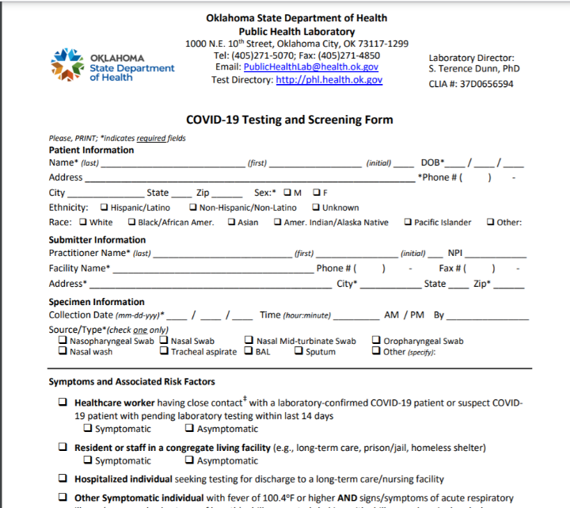

Points of perspective to remember:
Patient
Well-informed: what to expect, how to find resources, approximate time for results, without explicit guidance, suggest communicating a time of 5 days
Social needs are met where available
Encouraged to submit survey
Provide guidance to access results
Volunteers
Safety First!
Maintaining proper distance when completing forms and providing information
Wearing appropriate PPE
Readily accessible hand washing/sanitizing stations
Lab
Complete and accurate specimen labeling: patient identifiers First and Last Name (verified by sampler), RN initials, Date and time of collection
Barcode label does not cover any collection information written on original specimen label.
Health Department (Local and State)
Oklahoma State COVID Portal transmits testing information and results.
Complete Chain of Custody Form and double bagged specimens for proper specimen handling

