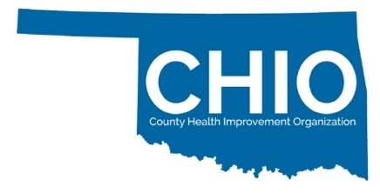
How to make your Certification ?
Connecting you to Health Improvement Opportunities through CHIO Certification

We are thrilled you are considering joining the CHIO network. There are many great ways to become involved with the CHIO network and help bring your CHIO certification to life!

CHIO Leadership (consider this your chairs, your decision makers, the overseeing body of your entity)
Monthly Research & Recruitment Opportunity Calls

CHIO General Membership (anyone belonging to the CHIO or OPHES networks, including leadership)
Monthly CHIO CHAT (virtual)
Quarterly “Communities in Action” Learning Series (virtual)
CHIO/PHIO Annual Meeting (in collaboration with the Rural Health Association of Oklahoma)
Bi-monthly e-newsletters showcasing the work of the CHIO network including opportunities

Making it Meaningful
We recognize it often takes a team to leverage up our existing work as we seek new opportunities for health care improvement. Your CHIO network is here to help with that! We encourage you to reach out to members of the PHIO and OPHES teams to support deepening your engagements. To learn more about other CHIO Certified entities are doing across Oklahoma please visit:
https://publichealthok.org/projects/catch-up/

We encourage you to learn more about the Community Partnership Program operated through the Public Health Institute of Oklahoma, the managing partner of CHIOs statewide. In 2012 PHIO created the Community Partnership Program (CPP) as an innovative pathway to support the delivery of funding to entities supporting health care improvement locally. Researchers, state-agencies, academics, philanthropic funders, and other healthcare improvement agents partner with PHIO and its stakeholders to design opportunities for communities to participate in health improvement activities while receiving Incentive Funds for their efforts. Incentive Funds are in turn re-invested into the community to address health disparities and inequities all while reducing barriers for local participation. The infusion of Incentive Funds through the CPP allows communities to respond to health and social care challenges at the local level. Incentive Funds are designed to address funding gaps, spark local innovation, and remove barriers to participation. Examples of efforts funded through the CPP: 5k/Fun Runs, pocket parks, health communication campaigns, food security outreach, opioid response, home-based visiting, community health workers, transportation, youth development, and social and health resource fairs. Since 2012 PHIO has distributed over $1.3 million dollars directly to communities and community members to support local health improvement efforts.

