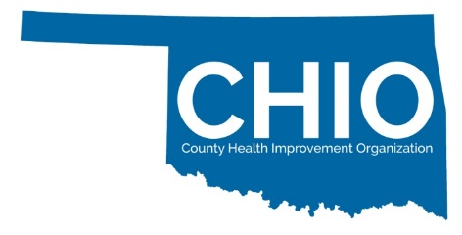
Certification Readiness Assessment Tool
Completion of this form helps us to determine your readiness for CHIO Certification which connects communities to health improvement opportunities.

Please note: Applying entities are not required to meet all CHIO Readiness elements. The CHIO Readiness Form and Application will serve as a Quality Improvement tool to assist your entity in achieving its health and wellness related goals. Recommendations will be provided by the CHIO Certification Review Committee upon review of your application.

This word document is designed to help you complete the form with your partners. You must submit the form online.

Entity
Name: ________________________________________________________________
Community/County(ies) served:________________________________________________________________
Primary Contact Name and Info (email, phone number): ______________________________________________________________________
Social Media Outlets (Facebook, Instagram, TikTok, others): ______________________________________________________________________

What type of CHIO Certification are you applying for?
☐ Community Health Improvement Organization
Your entity (or collective) serves individuals within one specified geography.
This could be at the census tract, zip code, town, city, or municipality level.
Examples include: local civic groups, faith-based organizations, small non-profits, local Chambers of Commerce, Local Governments, local primary and secondary educational institutions
☐ County Health Improvement Organization
Your entity (or collective) serves individuals within multiple geographies but constitutes no more than 2 entire counties.
This could include multiple census tracts, zip codes, towns, cities, or municipalities.
Examples include: large non-profits, local coalitions and task forces, special interest groups, local clinics and FQHCs, large faith-based organizations, philanthropic organizations, large civic organizations, financial institutions, vocational education institutions, law enforcement agencies
☐ County Health Improvement Organization +
Your entity (or collective) serves individuals within multiple geographies of a minimum of 3 or more counties.
This could include multiple census tracts, zip codes, towns, cities, or municipalities.
Examples include: large multi-county coalitions and task forces (3 or more counties served), hospitals and clinic systems, State Agencies, Tribes, Professional Associations, Special Interest Groups, financial institutions, vocational education institutions, law enforcement agencies, philanthropic organizations

1. ☐ YES ☐ NO Does your entity organize around health improvement priorities and/or goals to support your community and your community members?

2. ☐ YES ☐ NO Are you 501(c)3 or does an entity support your efforts?
If no, please name the entity supporting you: __________________________________

3. ☐ Urban ☐ Rural Do you serve an urban or a rural community?

4. Share with us who is involved in your health improvement activities?

- Primary Care
- Health Department
- Mental Health
- Social Services
- Faith Community
- Philanthropic Groups
- Hospital
- Businesses
- Extension System
- Financial Institutions
- Long Term Care
- Civic Groups
- Elected Officials
- Media
- Law Enforcement/First Responder/Public SafetyHigher Education
- FQHC/Community Health Centers
- Youth Development
- Child Development
- Dept. Health & Human Services
- Public Schools
- Other: ________

5. ☐ YES ☐ NO Do you have established communication channels to share information with the community?

6. ☐ YES ☐ NO Do you have health care providers participating in your health related activities?

7. ☐ YES ☐ NO Are you engaged or did you help with your Community Health Needs Assessment or County Health Improvement Plan activities as an entity?
8. Please indicate your organization’s alignment, if any, with the Oklahoma State Department of Health’s 2023 – 2028 Oklahoma State Health Improvement Plan’s health priorities: *

- Lack of Exercise/Cardiovascular Disease
- Behavorial Health
- Substance Misuse
- Poor Eating Habits/Obesity
- Diabetes
- Social Drivers of Health
- Adverse Childhood Experiences
- None at this time

These priorities were analyzed and published from the State Health Assessment.

9. ☐ YES ☐ NO Do you have established policies and procedures or by-laws as an entity?

10. ☐ YES ☐ NO Do you have a Board of Directors or a leadership structure supporting your entity?

11. ☐ YES ☐ NO Does your entity support a Parent Partnership Advisory Committee?

12. ☐ YES ☐ NO Does your entity support a Youth Advisory Committee or youth related programming?
13. ☐ YES ☐ NO Does your entity have the capacity to recruit & supervise community volunteers?

14. ☐ YES ☐ NO Does your entity have the ability to host virtual, web-based meetings?

15. ☐ YES ☐ NO Is your entity interested in participating in no-cost Continuing Education?

16. Please list the Top 3 health improvement goals for your entity over the next 5 years?
______________________________________________________________________
______________________________________________________________________
______________________________________________________________________
______________________________________________________________________
______________________________________________________________________
______________________________________________________________________
______________________________________________________________________

17. Are you a member of the following Professional Organizations:
☐ YES ☐ NO Oklahoma Primary Health Care Extension System
☐ YES ☐ NO Rural Health Association of Oklahoma
☐ YES ☐ NO National Rural Health Association
☐ YES ☐ NO Rural Health Network of Oklahoma
☐ YES ☐ NO Oklahoma Turning Point Council
☐ YES ☐ NO Oklahoma Public Health Association
☐ YES ☐ NO Oklahoma Center for Non-Profits
☐ YES ☐ NO Oklahoma Primary Care Association
☐ YES ☐ NO Other

18. ☐ YES ☐ NO Does your entity include community members in planning and leadership activities locally?

19. ☐ YES ☐ NO Does your entity remove barriers for community members to participate in planning and implementing health improvement activities locally (such as childcare, food, transportation assistance, stipend, etc)?

Thank you for completing your CHIO Readiness Assessment. Please email your CHIO Readiness
Assessment to info@publichealthok.org. A team member with the Public Health Institute
Oklahoma will be in touch to discuss next steps for completing your full CHIO Certification
Application. For your reference a brief timeline to provide additional details on next steps.

CHIO Certification Timeline and Checklist:
☐ Submit CHIO Readiness Assessment
Full application assistance and next steps provided by PHIO team
☐ Readiness Assessment reviewed and returned with recommendations by PHIO
Readiness Assessments reviewed as received
Next steps provided by the PHIO team.
☐ Complete full CHIO Certification Application
Please submit full applications 1 week prior to the start of each review month
☐ CHIO Certification Applications under review
Applications reviewed in: January, April, July, and October annually
☐ Notification of CHIO Certification
Certifications awarded in: February, May, August, and November
☐ Participation in Oklahoma Primary Health Care Extension System and CHIO activities
Ongoing after Certification, activities open to those with applications under review

Please note: Applying entities are not required to meet all CHIO Certification elements. The CHIO Certification Application will serve as a Quality Improvement tool to assist your entity in achieving its health and wellness related goals. Recommendations will be provided by the CHIO Certification Review Committee upon review of your application.

Questions? Need more information?
Laura Ross at (918) 931-9813
or laura@publichealthok.org
(405) 259-6851 or info@publichealthok.org
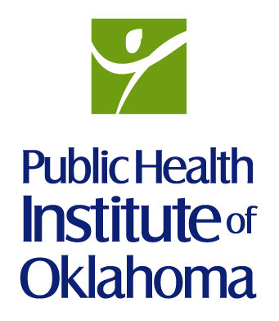
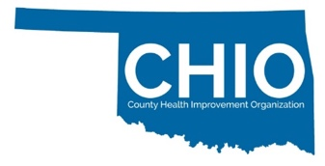
For more information visit www.publichealthok.org/CHIO

