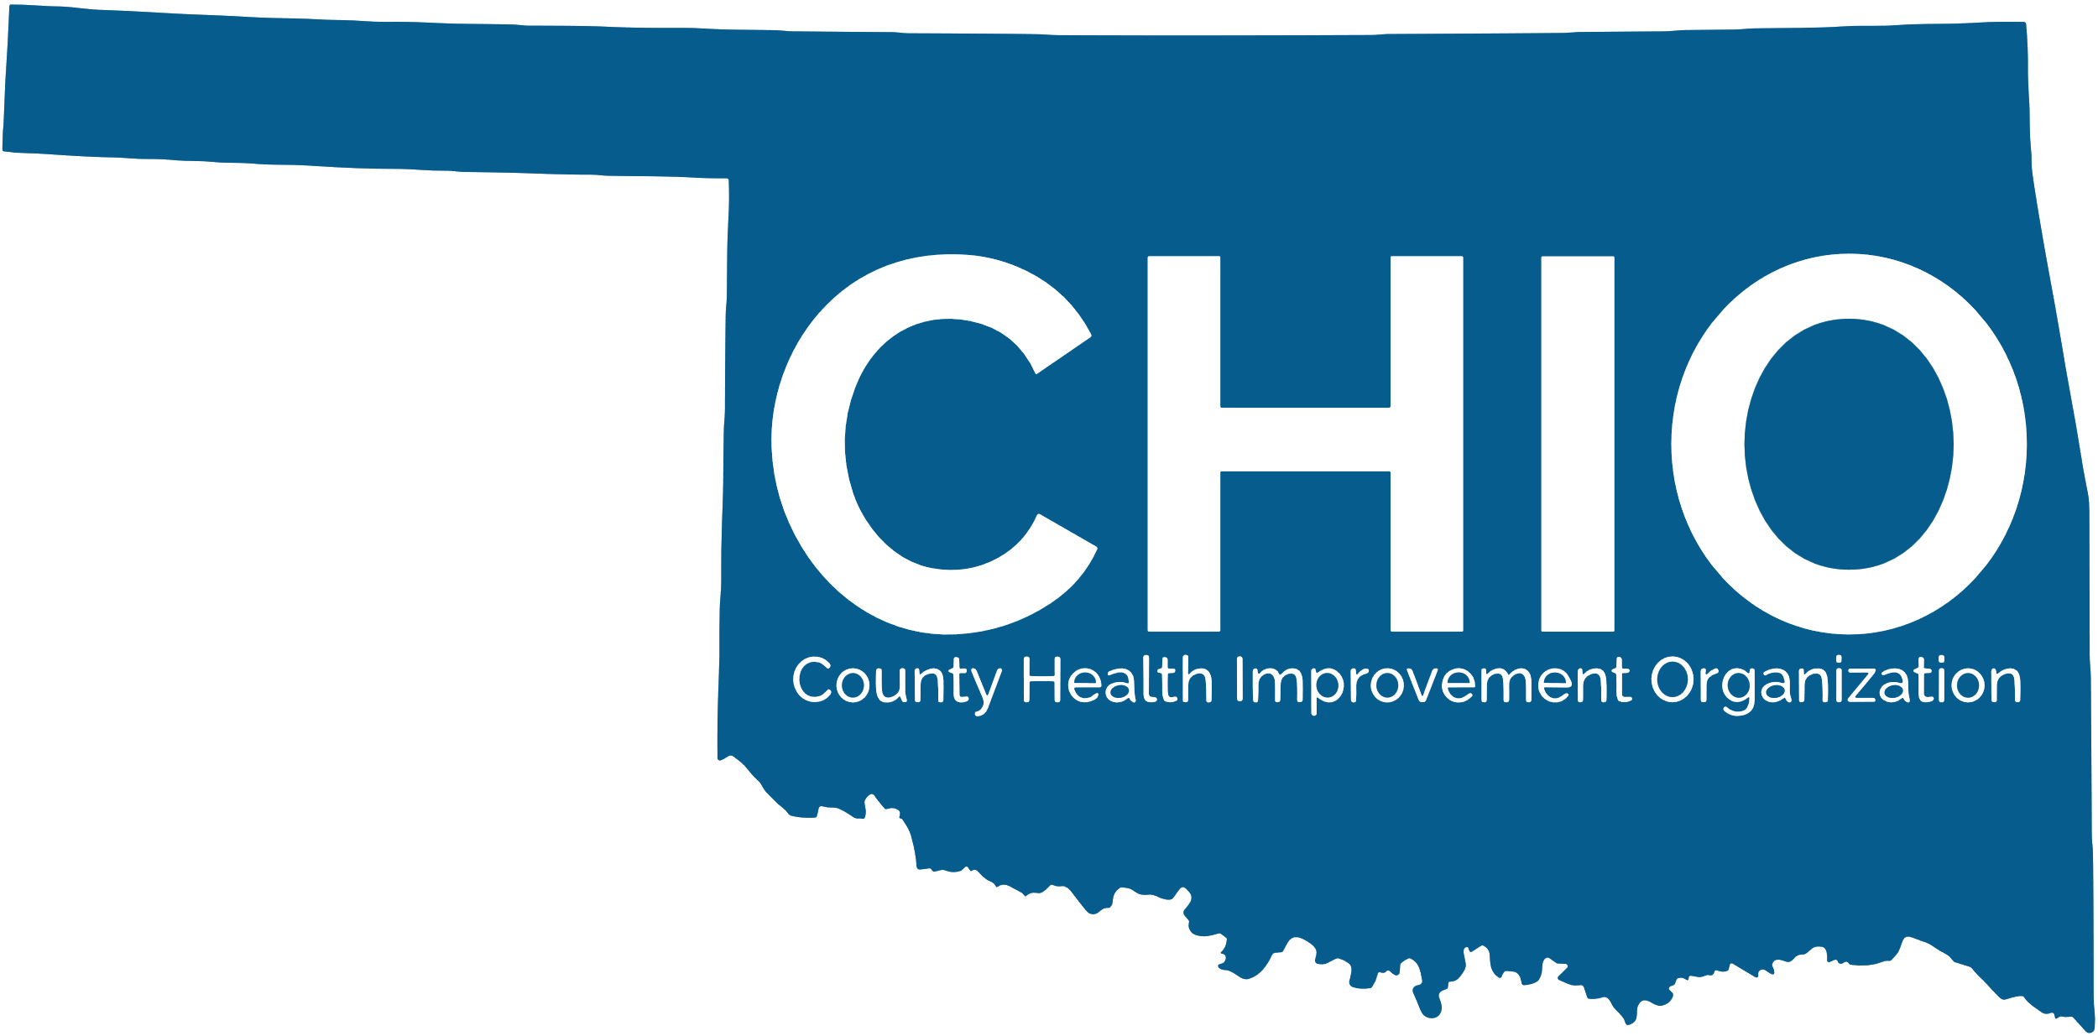
How to get CHIO Certified
Please utilize the following guidance to support the development of your CHIO Application. Team members from the Public Health Institute of Oklahoma are available for Technical Assistance while you work to complete your application
CHIO Certification Timeline and Checklist:
☐ Submit CHIO Readiness Assessment
Full application assistance and next steps provided by PHIO team
If you have already been cetified previously, begin with the application.
☐ Readiness Assessment reviewed and returned with recommendations by PHIO
Readiness Assessments reviewed as received throughout the year.
Next steps provided by the PHIO team.
☐ Complete full CHIO Certification Application

☐ CHIO Certification Applications under review
Next steps provided by PHIO team.
☐ Notification of CHIO Certification

Organizing to Complete your Application:
The PHIO Team recommends 3 approaches to completing your CHIO Certification Application: full group activity, committee/workgroup activity, or individual activity. Organizing details for each of these approaches can be found in the CHIO Certification Timeline document.

How to Submit your CHIO Certification Application:
You must submit your application through the online CHIO Certification Platform hosted by PHIO. You will be able to upload required documents on the web-based platform.

How your CHIO Certification Application will be Reviewed:
The CHIO Certification Committee represents PHIO board membes with experience in health and social services as well as community involvement.

How and what the PHIO Team will Communicate to you about your Application?
Please anticipate hearing from the PHIO team throughout the Certification process.

What to do after you are certified?
Look for opportunities to join in on shared learning, projects, planning, networking, and more!

