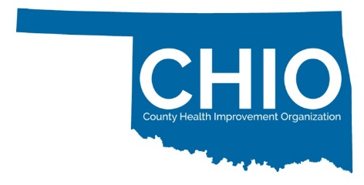
Certification Readiness Assessment Tool
Completion of this form helps us to determine your readiness for CHIO Certification which connects communities to health improvement opportunities.

Please note: Applying entities are not required to meet all CHIO Readiness elements. The CHIO Readiness Form and Application will serve as a Quality Improvement tool to assist your entity in achieving its health and wellness related goals.

This word document is designed to help you complete the form with your partners. You must submit the form online.

Entity Name:

Community/County(ies) Served:

Primary Contact Information:
- Name:

- Email:

- Phone number:

Were you referred by someone for the CHIO network? If so, whom?

Social Media Outlets (Facebook, Instagram, TikTok, others)

Website Address

Please provide your mission/vision or purpose statement.

Describe the programs and services your organization offers.

Select Your Certification Level:
Definition: Certification levels are based on geographic service area.

☐ Community Health Improvement Organization (cHIO)
- Serves individuals within one specified geography (census tract, zip code, town, city, or municipality).
- Examples: local civic groups, faith-based organizations, small non-profits, local Chambers of Commerce, local governments, local primary and secondary institutions.

☐ County Health Improvement Organization (CHIO)
- Serves individuals across multiple geographies with no more than 2 entire counties.
- Examples: large non-profits, local coalitions and task forces, special interest groups, local clinics and FQHCs, large faith-based organizations, philanthropic organizations, large civic organizations, financial institutions, vocational education institutions, law enforcement agencies.

☐ County Health Improvement Organization Plus+ (CHIO+)
- Serves individuals across 3 or more counties or statewide.
- Examples: large multi-county coalitions and task forces, hospitals and clinic systems, State Agencies, Tribes, Professional Associations, financial institutions, vocational education institutions, law enforcement agencies, philanthropic organizations.

Why is your organization interested in applying to become a CHIO?

Does your organization collaborative around health improvement prioritites and/or wellness goals to support your community and your community members?

Yes or No

Are you a 501(c)3 or does an external organization support your efforts?

Yes or No

If no, please name the organization supporting you.

What population does your organization serve?
rural
urban
both

Share with us who is involved in your local health improvement activities. Check all that apply.

- Primary Care
- Health Department
- Mental Health
- Social Services
- Faith Community
- Philanthropic Groups
- Hospital
- Businesses
- Extension System
- Financial Institutions
- Long Term Care
- Civic Groups
- Elected Officials
- Media
- Law Enforcement/First Responder/Public Safety
- Higher Education
- FQHC/Community Health Centers
- Youth Development
- Child Development
- Dept. Health & Human Services
- Public Schools
- Other

Do you have health care providers participating in your health related activities?

Yes or No

Are you engaged or did you help with your Community Health Needs Assessment or County Health Improvement Plan activities as an entity?

Yes or No

Do you have established policies and procedures or by-laws as an entity?

Yes or No

Do you have a Board of Directors or a leadership structure supporting your entity?

Yes or No

Does your organization meet regularly (monthly, quarterly, etc)?

Yes or No

Does your organization include community members in planning and implementing health improvement activities locally?

Yes or No

Thank you for completing your CHIO Readiness Assessment. A team member with the Public Health Institute of Oklahoma will be in touch to discuss next steps.

Please note: Applying entities are not required to meet all CHIO Certification elements. The CHIO Certification Application will serve as a Quality Improvement tool to assist your entity in achieving its health and wellness related goals..

Questions? Need more information?

Please email info@publichealthok.org or kayla@publichealthok.org

